**PROBLEM#06**

**Q** :Write a program to find **ASCII code** for a input number between **0 to 255** .

**SOURCE CODE:**

#include <stdio.h>

int main(){

int number;

printf("\n Enter any number between 0 to 225 \n ");

scanf("\n %d",&number);

switch (number)

{

case 0 ... 225:

printf("\n The ASCII character for %d is : %c \n",number , (char)number);

break;

default:

printf("Error: Invalid number.\n");

}

getch();

return 0;

}

**OUTPUT:**

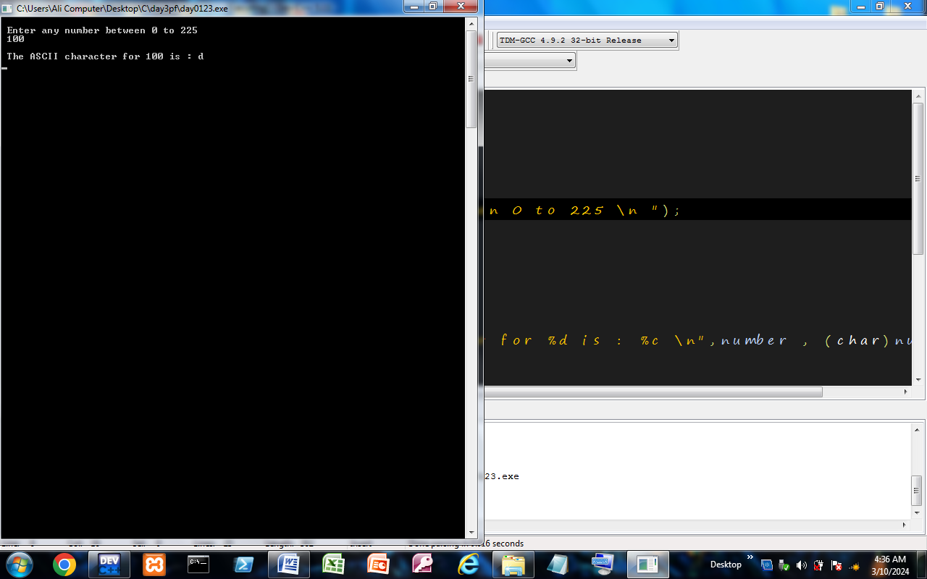

Made By :

***Kashan Ali Khan(BS-SE)***